Breast Cancer Early Detection using Explainable AI Models on ( Mammograms) images
Basel ashraf B,A

Abstract:

Introduction
Breast cancer is one of the most common cancer types , that affects a great percentage of the women and from every 50 women from 100 women that is affected with this tumor recognize and know that there are a tumor after the time is passed and the tumor is in its last stages and at this situation the possible options are two options some of the women decided to live with it despite of curing it fearing from the Disfigurement and this is the most wrong option
The other one is the cure it that the curing depends on the stage of the tumor if the tumor in the beginning and small in size and does not causing symptoms this means that
The tumor is Benign in the this case the solution is Observation, surgical removal; observation that doctors may recommend monitoring it over time with regular imaging (like ultrasound or mammogram) and surgical removal If the lump is large, painful, growing, or cosmetically concerning, a lumpectomy (surgical removal) may be done.
But on the other hand, if the tumor is malignant It goes under a huge process:
Surgery:
Lumpectomy: Removal of the tumor and a small margin of tissue.
Mastectomy: Removal of the entire breast (sometimes both).
Sentinel lymph node biopsy or axillary lymph node dissection to check if cancer has spread.
Radiation Therapy:Used after surgery (especially after lumpectomy) to kill remaining cancer cells.
Chemotherapy:Uses powerful drugs to kill cancer cells, often given before (neoadjuvant) or after (adjuvant) surgery.
Especially used for aggressive or later-stage cancers.
Hormone (Endocrine) Therapy:
For tumors that are hormone receptor-positive (estrogen or progesterone).
Medications like tamoxifen or aromatase inhibitors are used to block hormones.
Targeted Therapy: For HER2-positive breast cancer (tumors that overexpress the HER2 protein).
Drugs like trastuzumab (Herceptin).
Immunotherapy: Used in specific cases (e.g., triple-negative breast cancer) to help the immune system fight cancer.[4]

To sum up why we wait until the benign tumor comes malignant

“What if a single breakthrough could save millions of lives?
Imagine a world where breast cancer is detected early, accurately, giving women the power to fight back before it’s too late.”

After the technology and it latency and updating day by day using the deep learning and the explainability and intepretability techniques(XAI) allows us to learn and know and detect the tumor from its baby steps of growing to catch it and cure it so we go under this process and used ResNet50 ,DesNet121 and ResNet50 with some modifications in the parameters to get an approved accuracy than the first one with 84% accuracy and explained it with the partial dependency plot and other XAI techniques .

METHODOLOGY
The used dataset is The breast cancer dataset “CBIS-DDSM: Breast Cancer Image Dataset ” this dataset is collected from many patients with both types of tumor (benign and malignant) with almost 6990 patient of almost 1.5GB first we used a Kaggle notebook to implement our deep learning models which is ResNet50 ,DesNet121 and ResNet50 Modified and each one got its accuracy but before going deep with deep models we go first under some EDA process the most crucial one is the reading of the data itself as there are 5 files 4 of them contains the image paths but without identifying which is which and the remaining one contains the pathology but with no image paths but the key point that there are a common column which is the PatientID with the format of P-xxxxx so the data first goes and a fixing path and cleaning process which is responsible for the changing the way of writing the Column name to be suitable and ready for the joing process then he make dictionary with a map to assign each patientID with its image path and the pathology here is the first and crucial step then EDA is applied to test the main features and which feature have the most important features that contributes in identifying the tumor and this is defined using the correlation matrix and appeard that this is the breast density and from this plot it indicates that as long as the breast density increases the probability of the affecting with breast cancer increases
We labeled the benign and malignant with label encoder and after splitting the data into mass and train
Resnet 50 dense layer 256 and combined with 64 dense layer and the output is 1 layer and optimized using adam optimizer and added a early stop with patience 10 ephocs and monitored with val_auc and runs with 35 ephocs
DensNet121 dense layer 256 and combined with 64 dense layer and the output is 1 layer and optimized using adam optimizer and added a early stop with patience 10 ephocs and monitored with val_auc and runs with 35 ephocs
ResNet50 Modified dense layer 128 and combined with 256 dense layer and the output is 1 layer and optimized using adam optimizer and added a early stop with patience 10 ephocs and monitored with val_auc and runs with 35 ephocs

RESULTS
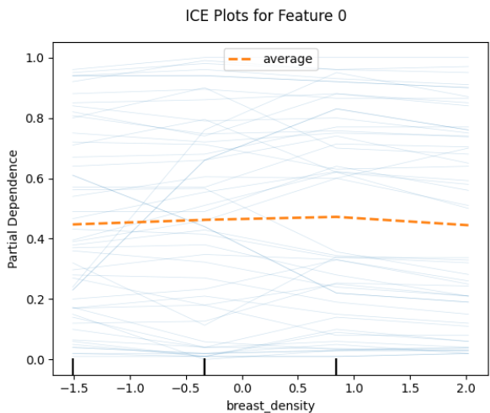
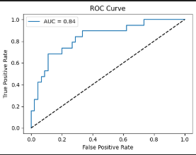
Based on the accuracy of the models : the Resnet50 modified model scores the higher acc as it scores 84% accuracy and plotted on a ROC curve but referning to the precesion and recall curve it presents that the model as long as it go deep to explore more the model fails to predict correctly and this problem is not in this model only I also in the other two models It may be from the amount of data as the data is little bit small and explained using the partial dependence plot (PDP) and individual conditional exception (ICE)

Figure (1) ResNet50 MODIFIED
accuracy

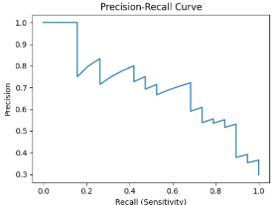
Figure (2) ResNet50 MODIFIED
Precesion-recall
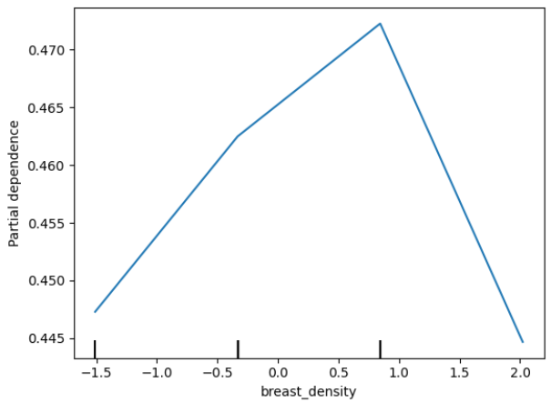
Figure (4) ResNet50 MODIFIED
(ICE)

discusion
the data is to small and not well organized and needs to be re constructed and due to these problems that the models cannot get a high accuracy and as long as the model go deep it fails to predict correctly , also the data must be balanced as the data is biased to the benign and this will affect the model prediction as he learned more about the benigns more than the others

CONCLUSION

references
- H. Dhahri, E. A. Maghayreh, A. Mahmood, W. Elkilani, and M. F. Nagi, “Automated breast cancer diagnosis based on machine learning algorithms,” Journal of Healthcare Engineering, vol. 2019, pp. 1–11, Nov. 2019, doi: 10.1155/2019/4253641.
- K. A. Kovács et al., “Machine learning prediction of breast cancer local recurrence localization, and distant metastasis after local recurrences,” Scientific Reports, vol. 15, no. 1, Feb. 2025, doi: 10.1038/s41598-025-89339-9.
- M. a. V. M. Grinet, N. M. Garcia, A. I. R. Gouveia, J. a. F. Moutinho, and A. J. P. Gomes, “Reduction of surgical risk through the evaluation of medical imaging diagnostics,” arXiv.org, Mar. 08, 2020. https://arxiv.org/abs/2003.08748
- Patel A. Benign vs Malignant Tumors. JAMA Oncol. 2020;6(9):1488. doi:10.1001/jamaoncol.2020.2592

Figure (3) ResNet50 MODIFIED
(PHP)

